Show Metadata…

CUSTOMER

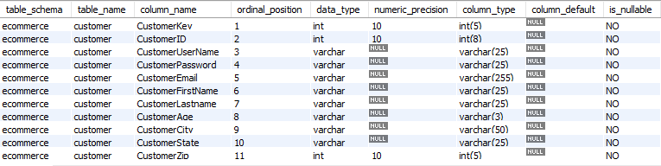

COMPANY

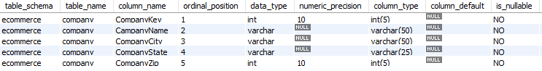

CREDIT_CARD

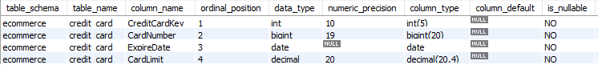

ITEM

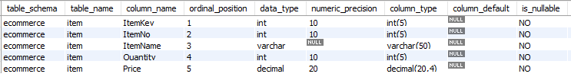

WEB_BUSINESS



ORDERS



CALENDAR

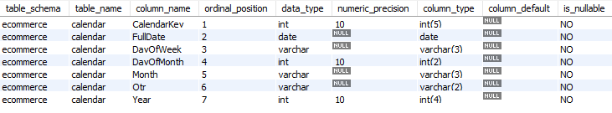

SALESFACT

